# Temiskaming Crops Coalition/Cochrane District Soil & Crop Improvement Association

Rapid Development of Farmland from Boreal Forest and an Evaluation Relative to Traditional Clearing Methods

*2017 Final Report*

## Funding for this project was provided through a Tier Two grant supported by the Ontario Ministry of Agriculture, Food and Rural Affairs and the Ontario Soil and Crop Improvement Association.

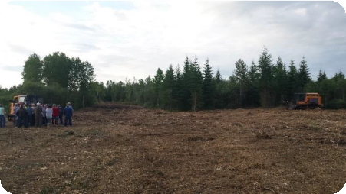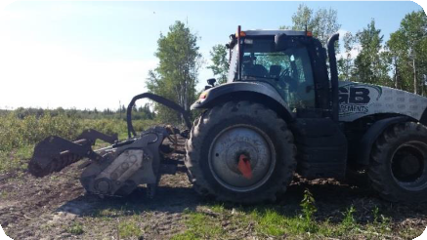

**This project would not have been possible without the support and commitment from project partners:**

# *GB Equipment*, located in Sainte-Brigitte-des-Saults, Quebec, provided both rounds of land preparation (surface mulching & subsoiling) as an in-kind contribution. Further information on GB Equipment and their services can be found at [www.gbequipment.ca](http://www.gbequipment.ca/)



*Carl Dodds & Will Runnalls*: the producer cooperators have donated acres for the duration of the project and have donated their time and equipment for various activities, including timbering, planting, harvesting, etc.

## OMAFRA: Dan Tassé, Tom Hamilton, Barry Potter Project Steering Committee

# Project Summary

This three-year project had two main objectives: (1) to assess the soil impacts and crop growth potential resulting from a mulching/subsoiling process and (2) develop a business case that will evaluate mulching and other methods of traditional land clearing. Two sites were mulched and sub-soiled in 2015, with forages and crops planted in the two following years. Based upon soil samples and field monitoring, a viable crop can be grown immediately after mulching, however yields were less than those on the conventionally cleared plot. The level of organic matter and the carbon-nitrogen ratio are increasing at a faster rate on the mulched plot compared to the conventional plot.

Management strategies for future mulching could consider:

* Complete mulching in the fall, let the residue winter on the ground and subsoil in the spring
* Plant a high biomass crop for the first year or two to give wood residue time to break down and further incorporate within soil
* Broadcast or aerial seeding to reduce seed displacement caused by mulched seedbed.
* Thoroughly incorporate the woody material into the seedbed – seedbed preparation is key to proper seed placement.
* Monitor soil health with soil sampling and add amendments according to results. High levels of fertilizer will likely be necessary, especially for mulched fields. This is also an important consideration for land clearing in general.

A second objective was to develop a business case evaluating mulching and other methods of traditional land clearing. This reference document considers four key phases that could exist prior to clearing and provides information on the process, timing, cost, end-use, pros, cons & considerations for each. The four phases can be assessed separately or together, depending on the characteristics of the land to be cleared. The document can be found at [www.nofia-agri.com](http://www.nofia-agri.com) or at [www.farmnorth.com](http://www.farmnorth.com).

Introduction

This three-year project has two main objectives: (1) to assess the soil impacts and crop growth potential resulting from a mulching/subsoiling process and (2) develop a business case that will evaluate mulching and other methods of traditional land clearing. Based on outcomes from this project, mulching and its role in agriculture will be better understood and producers will have sound information necessary to make informed decisions regarding their land management practices.

Project Background

Northern Ontario contains a vast amount of Class 2, 3 and 4 land which is not currently in production (4+ million acres). Some of this land was farmed in the past, but has lain idle for many years and has grown in up in scrub bush. Other blocks have had mature trees harvested and are now covered in successional scrub and trees, while other areas contain mature tree stands.

To convert these areas into productive farmland, the tree stems and large branches have to be physically removed, burned or mechanically processed in place. Stumps and roots may be excavated or raked out and removed from the site, piled and burned, left in the ground to rot or mechanically processed on site.

The use of large industrial shredder/grinders to process standing stems, slash, and root beds is increasing in the North. Information on the long-term effectiveness, cost efficiency, and suitability for agricultural purposes of these machines is lacking. Some of this cleared land has seen successful crop growth afterwards and some has not – this could be attributed to many factors including method of mulching, tree composition, volume of woody material incorporated, etc. It is anticipated that this study will provide initial information related to these variables and how they could potentially impact future crop growth.

Project Progress

In 2015, the project sites were selected, baseline soil sampling and a forest inventory was completed and all land preparation, including mulching, subsoiling and installing tile drainage, was completed.

In 2016, both sites were planted with a combination of clover, oats and buckwheat, underwent spring and fall soil sampling, plant tissue analysis and a plant count.

In 2017, both sites were planted with a cash crop to further asses yield potential. A reference guide was developed that assessed different stages of land clearing and relevant methods to complete.

Project Sites

Cochrane

The Cochrane site was planted on June 29th, 2017 with 6 alternating rows of Dieter wheat (~5.2 acres) and Wilkin oats (~4.7 acres) in the mulched section and a row of wheat and oats in the conventional section. A strip of the field was left with 2016 planted clover, but the rest of the site was desiccated in the spring and the ground was lightly worked before the wheat and oats were planted. Oat strips received 170 lbs/acre of 8-32-16 in the drill and 80 lbs/acre of 46-0-0 broadcast and wheat strips received 280 lbs/acre of 8-32-16 in the drill and 100 lbs/acre of 46-0-0 broadcast. A first cut on the clover was completed during the last week of June – due to the late planting and the detrimental growing season, a complete harvest of the site was unsuccessful.

Temiskaming

The Temiskaming site was planted on June 15, 2017 with alternating rows of Dieter wheat and Wilkin oats. Prior to planting, the site was desiccated and disked. Oat strips received 60 lbs/acre of 8-32-16 in the drill and 100 lbs/acre of 46-0-0 broadcast and wheat strips received 140 lbs/acre of 8-32-16 in the drill and 130 lbs of 46-0-0 broadcast. Oats were seeded at 130 pounds/acre and wheat was seeded at 150 pounds/acre. Harvest wasn’t completed on the site during 2017 due to poor overall growing conditions.

Results

With challenging growing conditions in 2017, yield information for both sites is limited. Plant counts, soil samples and tissue samples from both sites provided a better understanding of the impacts and potential of mulching agricultural land. Based upon the 2017 soil sampling, tissue analysis and plant count, the soil impacts and crop potential of mulched land and traditionally cleared land was assessed. Over the past two years, a viable crop has been grown on newly mulched land, though this crop has been less successful than the crop grown on the adjacent conventionally cleared plot.

Plant Counts

As with 2016 results, higher plant counts were seen in the conventionally cleared land vs. mulched land, except for the previous year’s clover.



28%

Higher plant count in conventional plot vs. mulched plot



20%

Higher plant count in conventional plot vs. mulched plot

20%

Higher plant count in conventional plot vs. mulched plot

Soil & Plant Health

With a second year of soil sampling after clearing in Cochrane, some changes is the soil are evident – organic matter and the C:N ratio significantly increased pre and post mulch. The C:N ratio also increased pre and post conventional, but not to the same degree. Phosphorous increased on both plots.

|  |  |  |  |  |  |
| --- | --- | --- | --- | --- | --- |
|  | Organic Matter | Phosphorus P-ppm Bicarb | Potassium K ppm | pH | C:N Ratio |
| **Average pre-conventional** | 8.3 | 5.0 | 79.5 | 7.0 |  |
| **Average post-conventional 2016** | 8.8 | 7 | 87.5 | 7.2 | 9.99 |
| **Average post-conventional 2017** | 6.98 | 14.71 | 80.85 | 6.99 | 10.8 |
| **Average pre-mulch** | 6.6 | 3.5 | 86.1 | 6.8 |  |
| **Average post-mulch 2016** | 6.7 | 10.1 | 107.0 | 7.0 | 9.4 |
| **Average post-mulch 2017** | 10.14 | 11 | 54 | 7.2 | 12.47 |

**Soil Sample Results from 2015, 2016, and 2017 at the Cochrane site**

Two years after clearing, with significant amendments based on soil sampling, the plot continues to exhibit nutrient deficiencies in phosphorous, sodium, sulfur, zinc, manganese and boron. Both the oats and wheat were deficient in boron and sulfur but had normal levels of other nutrients, with no difference between conventional or mulched land.

In Temiskaming, phosphorous also increased, as did the C:N ration. However, organic matter slightly decreased.

|  |  |  |  |  |  |
| --- | --- | --- | --- | --- | --- |
|  | Organic Matter | Phosphorus P-ppm Bicarb | Potassium K ppm | pH | C:N Ratio |
| **Average pre-mulch** | 7.1 | 5.5 | 40.8 | 7.4 |  |
| **Average post-mulch 2016** | 7.3 | 5.5 | 55.8 | 7.6 | 9.4 |
| **Average post-mulch 2017** | 6.7 | 8.3 | 48.1 | 7.3 | 9.9 |

**Soil Sample Results from 2015, 2016, 2017 at the Temiskaming Site**

Two years after clearing, Temiskaming is also exhibiting nutrient deficiencies in phosphorous, potassium, sodium, sulfur, zinc and boron. The wheat had low levels of phosphorous and deficiencies in boron and manganese. At the Temiskaming site the wheat plants showed very low levels of phosphorus and deficiencies of boron and manganese. The oats also showed low levels of phosphorus, boron and manganese.

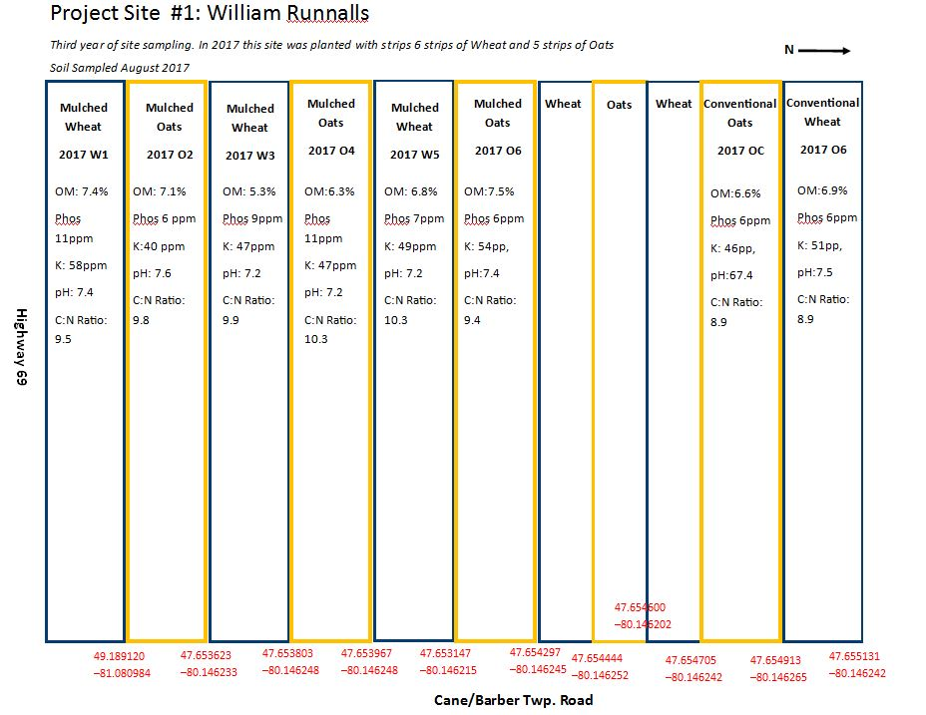

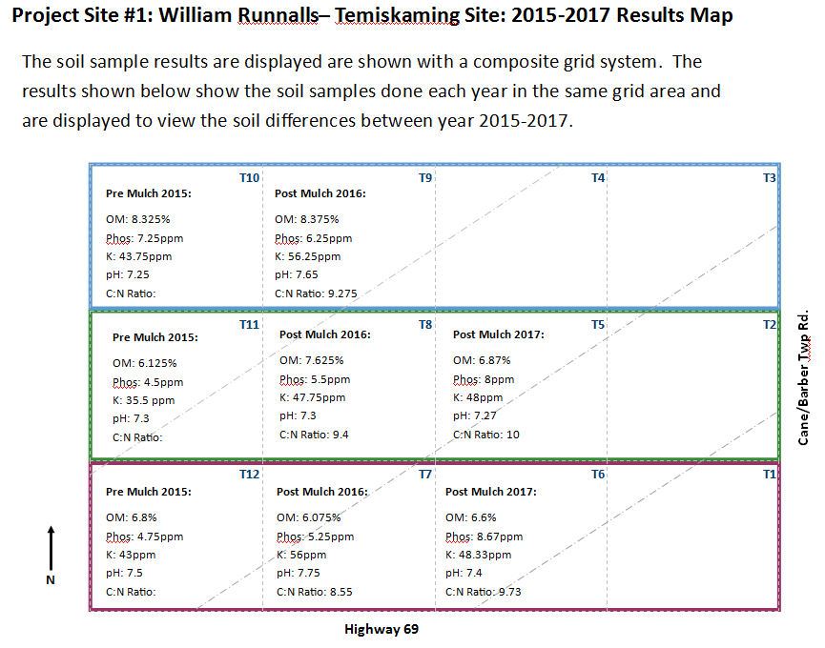

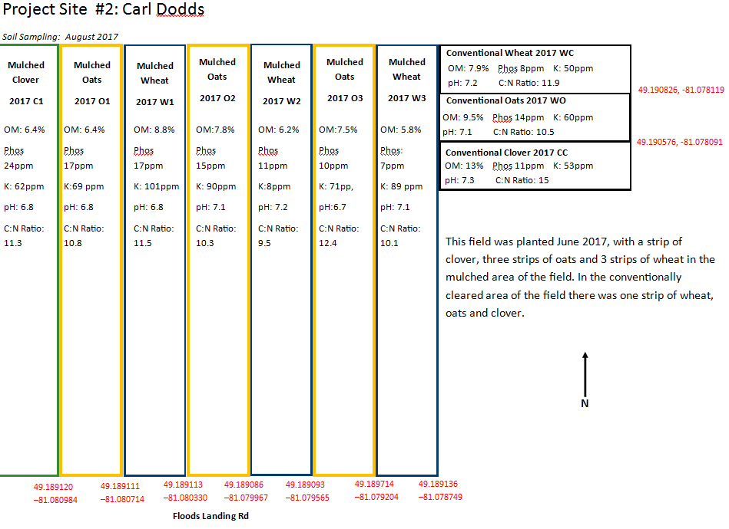

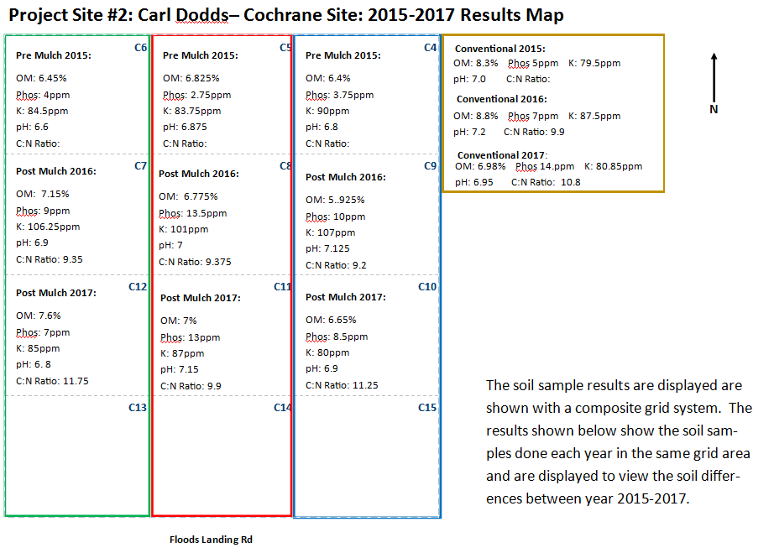

Discussion

During the project planning stage, two factors were identified that might impact future crop potential on mulched sites: (1) the importance of seed bed preparation to ensure that woody residue did not impact seed placement and (2) the potential for incorporated woody residue to impact the carbon-nitrogen ratio and cause potentially harmful impacts to soil fertility. 2016 results indicated that both plant counts and plant vigor were less in the mulched plot compared to the conventional plot, but that soil parameters hadn’t changed significantly pre- and post-clearing. Based upon 2017 results, the plant counts and plant vigor were again better in the conventional plot compared to the mulched plot. Soil parameters between the conventional and mulched plots also began to differ, with a greater increase in the organic matter content and carbon nitrogen ratio in the mulched plot.

One of the factors impacting plant growth is the seeding bed during seeding time, as woody residue on the surface and integrated into the soil impacts the number of seeds able to sprout. This results in lower plant counts and in some cases stunted plant growth with seeds that were planted too deep or too shallow. Seedbed preparation and the thorough incorporation of the woody residue is important to ensuring crop success. If too much mulch is left on the soil surface seeds will not be able to establish in the soil.

Generally, land clearing increases organic matter as residue is left in the soil to breakdown. With mulching, more residue is incorporated into the soil, so there may be a greater increase in organic matter, which was seen in Cochrane where large amounts of wood were mixed with the soil. Levels of organic matter in mulched soil may also decrease slower than levels in conventionally cleared land since a high percentage of the mulched material is buried in the soil, reducing its exposure to oxygen and sunlight and slowing decomposition.

Organic material in the form of wood (with high amounts of lignin) is difficult for micro-organisms to break down. When mulched, the surface area of the wood increases, allowing for increased rates of decomposition. With these high rates of decomposition, the micro-organisms will use a large amount of nutrients found in the soil, which will leave little nutrients for the crop. It will be important for the farmer to properly monitor his field and apply fertilizer to feed the crop and help with further decomposition. As the mulch decomposes, the C:N ratio will continue to rise as carbon is released into the soil from decomposed wood. As the current ratios are quite low, this won’t be detrimental to the site.

Generally, newly cleared sites also have low fertility. The crops within the 2017 project year showed low levels of boron, sulfur, phosphorus and manganese. Boron impacts the plant’s cell wall growth and overall plant structure. A lack of boron could impede on the plants ability to have a strong wall, causing higher chances for lodging. Sulfur deficiency can impact a plants protein synthesis, chlorophyll production and plant structure, therefore with limited levels of sulfur the crop can be majorly impacted. Low levels of phosphorous in a plant will highly impact the plants. Phosphorus is one of the most important nutrients for the plants, playing a key role in producing ATP (stored energy), in plant cell growth (with DNA and RNA) and many other metabolic cycles. With a phosphorus deficiency plants will end up being stunted and have lower yields. A manganese deficiency is often found in soils where there are higher levels of organic matter or high pH levels. Plants with low manganese levels will show yellowing in the leaves and in severe cases can see yield loss and foliage death.

With the projects results thus far, recommendations for producers who are considering mulching include:

* Complete mulching in the fall, let the residue winter on the ground and subsoil in the spring
* Plant a high biomass crop for the first year or two to give wood residue time to break down and further incorporate within soil
* Consider broadcast or aerial seeding to reduce seed displacement caused by mulched seedbed.
* Thoroughly incorporate the woody material into the seedbed – seedbed preparation is key to proper seed placement.
* Monitor soil health with soil sampling and add amendments according to results. High levels of fertilizer will likely be necessary, especially for mulched fields.

A potentially important consideration that was not quantifiable within the scope of this project is the implication of keeping all top soil/organic matter on-site, which occurs with mulching. Traditional land clearing can remove significant amounts of soil, and the environmental and economic impact of that loss is difficult to assess. When mulching, all material is left on-site, which could provide significant long-term benefits in soil fertility compared to some forms of traditional land clearing.

Land Clearing Reference Guide

A second objective was to develop a business case evaluating mulching and other methods of traditional land clearing. This reference document considers four key phases that could exist prior to clearing and provides information on the process, timing, cost, end-use, pros, cons & considerations for each. The four phases can be assessed separately or together, depending on the characteristics of the land to be cleared. The document can be found at [www.nofia-agri.com](http://www.nofia-agri.com) or at [www.farmnorth.com](http://www.farmnorth.com).

Future Steps

NOFIA will likely continue to monitor soil health and yield potential for the Cochrane site, since this site has a mulched and conventional plot to compare results. It is expected that soil parameters will continue to change and long-term monitoring will provide information on these changes.

With the outcomes from this project, the implications of mulching are better understood – it is possible to mulch and sub-soil land and plant a viable crop immediately afterwards. However, newly cleared lands are usually very poor in inherent soil fertility and further research needs to be done to understand how to improve their fertility through the application of fertilizers, manures, legumes & grasses and cover crops/or perennial crops.

2016 Cochrane Project Summary



2016 Temiskaming Project Summary

